STATE OF NEVADA
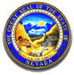

BOARD OF VETERINARY MEDICAL EXAMINERS
4600 Kietzke Lane, Building O-265
Reno, NV 89502
Phone 775-688-1788/Fax 775 688-1808
vetbdinfo@vetboard.nv.gov
https://nvvetboard.nv.gov

08/23/2021
This is to certify that a standard search of the records available in this office indicates the following:
NAME OF LICENSEE: Erin Ostrow, LVT
WAS ISSUED LICENSE #: LVT656
ON: 05/10/2010
LICENSED BY: VTNE; NV Jurisprudence
LICENSE STATUS: Active
LICENSE EXPIRATION: 12/31/2021
DISCIPLINE: None
COMMENTS: None

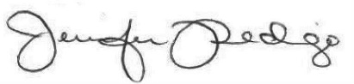
Jennifer Pedigo
Executive Director

